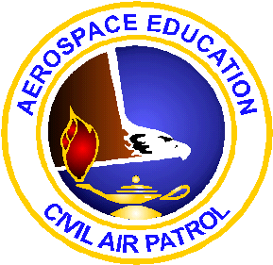
NATIONAL AEO SCHOOL
June 19-22, 2018
NAVAL AIR STATION PENSACOLA
PENSACOLA, FLORIDA

Application to attend: (Note: Tuesday, June 19 will be devoted to providing information about an AEO’s duties/responsibilities that will lead to achieving the Technician Rating.) June 20-22 will emphasize hands-on activities, including STEM Kits, and field trips to watch the Blue Angels flight team practice and to launch rockets. Return completed application to Dr. Jeff Montgomery, Director, Aerospace Education, National Headquarters, CAP, 105 S. Hansell St., Bldg. 714, Maxwell AFB, AL 36112-5937 or email your application to jmontgomery@capnhq.gov. You will be notified of the status of your application.

Name: _______________________________________________________________

Street Address: _______________________________________________________

City _______________________, State _______, Zip ______________

Daytime Telephone: __________________________________________

Email address: ______________________________________________

Your CAP Rank: _____________________________________________

Your CAP Member Number: _______________ Current Wing: _______
Current position in CAP: _______________________________________

How long have you been assigned to the AE Program? ________________

You will be contacted to confirm your application.

