The “5 M’s” for Coronavirus
Special Risk Considerations During COVID-19 Crisis

This document is meant to supplement the “5 M’s” Guide to Risk Assessments. The Coronavirus demands that we look at a new set of hazards so we can reduce the risk of being exposed to the virus or inadvertently spreading the virus. These are just a few of the areas to consider as you fill out
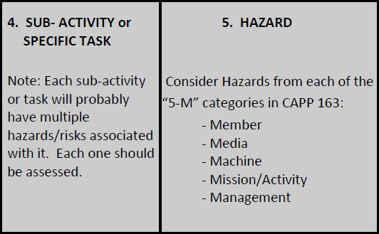
Using the 5 M’s in A Risk Assessment:

Here is what you will see when you look at Steps 4 & 5 of the CAPF 160:

Step 1: The Plan. Look at the whole plan for the entire activity. You may want to go through in order and write down every task that may have a chance of exposing you to the coronavirus … everything you touch or people you encounter.
Step 2: The Hazards. Using the 5 M’s, as described below, ask yourself “what can go wrong?” How does this task expose you to the virus? Then you’ll be able to apply a risk control to each of those exposure risks.

Member: Take a look at all the information about the members themselves. A few examples:
- Is the member “mission essential?”
- Has the member been anywhere that may have exposed them to the virus?
- Is the member over the age of 65, or does them member have any health conditions like
diabetes, heart disease, respiratory illness, lung problems, or anything else that may increase
the risk of a bad income if they catch COVID-19?
- Does the member live with anyone who may have the conditions listed above?

Medium: This refers to the environment you’ll be facing.
- Will multiple members be in close proximity (in a vehicle? In an airplane?)
- Does the mission area allow for adequate social distancing?
- Has the area been sanitized? Is the area equipped with adequate hand-washing or sanitizing
resources?

Machine: This applies to the airplane, the vehicle, the gear that will be used.
- Has the aircraft or vehicle been cleaned IAW with CAP/LG guidelines?
- Does the plan include cleaning all equipment following its use and prior to storing?

Mission: This looks at the plan itself and the complexity of the mission.
- Is the mission essential?
- Is the mission or activity included in CAP/CCs list of approved activities and missions?
- Is there a way of completing the activity online, on the phone, or through virtual meeting?

Management: This refers to the organizational factors that influence our activities and missions.
- Are you complying with the current guidance from CAP NHQ and the National Commander?
- Are you complying with all guidance from local, state, and national authorities?

IMPORTANT NOTE: These are just a starting point to help you look at all exposure risks. The goal through the entire activity is to actively ask, and answer:
“what can expose me to the virus, and what am I doing to prevent it?”

