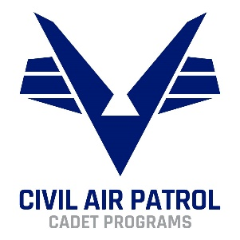
CADET PROGRAMS
ADULT EDUCATION EVALUATION
Request for Insights

Thank you for your willingness to share your insights with the National Cadet Team! We are very excited to better understand the realities of the current programs. Please be honest in your responses; our aim is to make a better program.
Below is a long list of areas we are interested in exploring. Please don’t feel like you must answer every question. Feel free to just pick the ones you feel most connected to, and feel free to add anything that might not be on the list.
We truly appreciate the time you are taking to improve the cadet program.

TLC
- What are the problems with the Current TLC course/process? If you have thoughts on how to improve, please include that.

- How would you feel if some of the direct instruction that happens in TLC was changed to online modules, to open up space in the in-person course for more group discussion or scenario-based activities? Procs/cons of this?

- How do you feel about the current way to refresh?
  - What do you feel like would be a good way to refresh?
  - How would you feel about a system of continuing education credits (after X years you need to have completed X credits to keep “TLC” current)?

- What resources would make implementing TLCs more effective for your wing?

GENERAL TRAINING

- As it relates to Cadet Programs, do you feel the onboarding process for new members (or cadets becoming senior) is clear? If not, how would you improve that, especially as it is related to cadet programs?

- How would you feel about a “New Adult Welcome Course” that was fully online, available at the members’ convenience, which would orient them to the basics of CAP?

- Do you feel like you have enough training to do your duty position well? What would be helpful?

- Are there enough training & resources in CAP to help adults understand how to work with youth?
  - Topics like:
    - Mentoring & relationship building with today’s teens
    - Dealing with cadets in crisis
    - Facilitating small group discussions
    - Strategies for engaging instruction
    - Etc.
  - What topics would you like to see included somewhere?

- Do you feel that leaders of large-scale cadet programs (ENC, NCSAs) have enough training/resources? If not, what would be helpful?

SPECIALTY TRACK

- What problems do you see with the current Cadet Programs Specialty Track?

- How would you feel about a Youth Development Specialty Track? The CP Specialty Track focuses on the operations of the cadet program, where the YD specialty track could focus on the youth development side of things. Pros/cons of this idea?

OTHER
- What other problems do you wish NHQ would address, as it relates to Cadet Programs?

- Anything else you would like to share?

