department of the air force
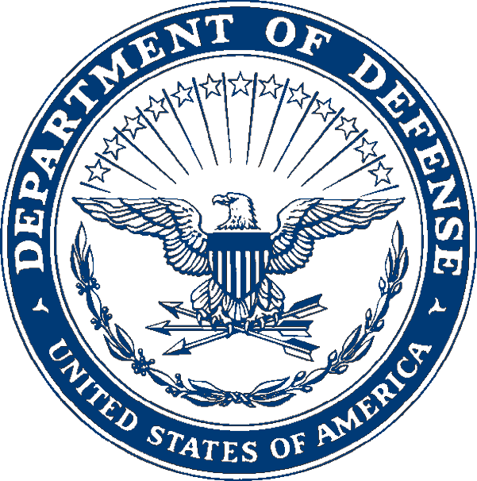
Applicable CAP-USAF Unit
Applicable CAP-USAF Unit Street Address
CAP-USAF Unit City ST Zip+4

MILITARY SUPPORT AUTHORIZATION DD Mmmmm YYYY

NO. YY-##

The following Civil Air Patrol members are authorized use of military and Air Force facilities/services at Name of Military Installation during the period Inclusive Dates, for the purpose of state purpose of why CAP members require access to the installation. Military quarters and military surface transportation are authorized in accordance with AFI 10-2701 on a space available basis in accordance with host installation procedures. Members are authorized medical care in accordance with AFI 10-2701 and AFI 41-210. Use of military messing and officer's club facilities have been approved. Use of exchange will be limited to essential items as outlined in CAPR 147-1 and AFI 34-211(I). Training is authorized in accordance with AFI 10-2701. Host installation mission requirements may result in short notice changes precluding use of above facilities and services; therefore, personnel should possess sufficient funds to defray cost of commercial, off-base lodging and meals, should this event occur. Activity is an approved CAP program in compliance with AFI 10-2701.

GRADE LAST NAME FIRST NAME SSAN
111-22-3333 or last four

CAP-USAF Approving Official's NAME, Rank, USAF DISTRIBUTION
Approving Official's Duty Title 1 – Individual
1 – File

NOTE: Prior to individual distribution, omit all SSANs except for the intended member. Delete this statement before signing the authorization.

