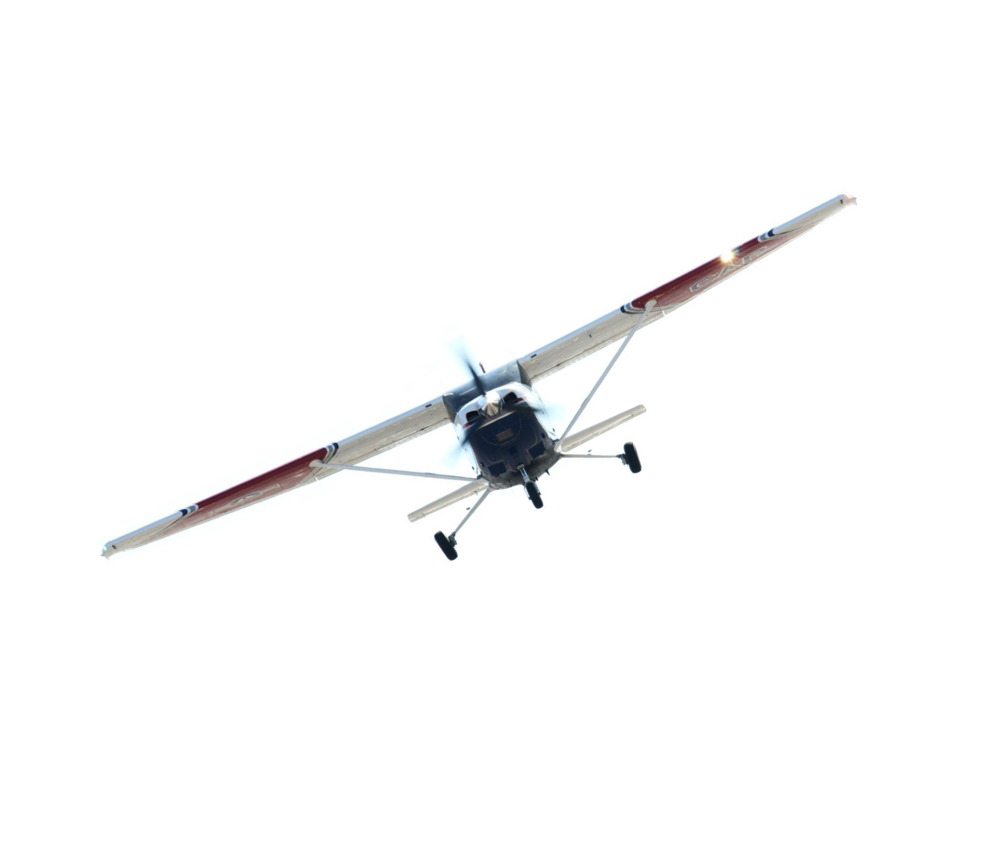Civil Air Patrol
Strategic Plan

Annex 2017

2
Annex 2017

We Are Civil Air Patrol

Our Vision Statement
Civil Air Patrol, America’s Air Force auxiliary, building the nation’s finest force of citizen volunteers serving America.

Our Mission Statement
Supporting America’s communities with emergency response, diverse aviation and ground services, youth development, and promotion of air, space and cyber power.

Our Core Values
Integrity – Volunteer Service – Excellence – Respect

Our Slogan Our Motto
Citizens Serving Communities Semper Vigilans

- To provide an organization to -

Our Purpose

  - encourage and aid citizens of the United States in contributing their efforts, services, and resources in developing aviation and in maintaining air supremacy; and
  - encourage and develop by example the voluntary contribution of private citizens to the public welfare.
- To provide aviation education and training especially to its senior and cadet members.
- To encourage and foster civil aviation in local communities.
- To provide an organization of private citizens with adequate facilities to assist in meeting local and national emergencies.
- To assist the Department of the Air Force in fulfilling its noncombat programs and missions.
36 U.S.C. §40302

Our Priorities
- Be a vigorous part of the Total Force – enhance the relationship with our USAF and contribute to their mission accomplishment as a cost effective force multiplier.
- Build Partnerships – increase our presence in national and local communities to better serve America and expand our portfolio to incorporate new missions for which we are ideally suited.
- Inspire ingenuity – increase efficiencies in time and effort to enhance the effectiveness of CAP members.
- Be America’s STEM leader – promote CAP’s recognition as a leader in Aerospace Education and Science, Technology, Engineering and Math education to meet America’s needs of tomorrow.
- Make being a CAP member even more special – recognize the value and talent of each CAP member; increase the fun and enhance fulfillment of the CAP experience to make members want to stay and others to want to join.
- Build the future – develop CAP’s organizational as well as functional leaders, from cadet to CEO.
- Set the example – sustain institutional excellence.

Year 2017 Goals & Objectives

Priority 1: Be a vigorous part of the Total Force – enhance the relationship with our USAF and contribute to their mission accomplishment as a cost effective force multiplier.

As a valued partner in the Total Force, our efforts should complement the Air Force's non-combat missions and programs, both existing and envisioned. As a member of the Total Force, it's our duty to recognize opportunities to present cost effective alternatives that fulfill Air Force needs.

Goal 1.1: Increase opportunities to partner with the Air Force
Objective 1.1.1: Semiannually, discuss with Air Staff on possible missions CAP can perform to help increase Airmen readiness and Quality of Life
Objective 1.1.2: Annually, or following the transition of a new Chief of the National Guard Bureau or Director of the Air National Guard, provide a capabilities briefing to highlight opportunities to partner with CAP
Objective 1.1.3: Annually, produce one article for each of the three recruiting services' periodicals
Objective 1.1.4: Annually, or following the transition of a new State Adjutant General, provide a capabilities briefing to highlight opportunities to partner with CAP
Objective 1.1.5: Annually, extend invitations to military installation leadership within the state (active, Guard and Reserve) to observe CAP activities, especially those held on installations

MER Strategies

1.1.a: Streamline our staffing function to mirror the staff functions used by USAF
1.1.b: Increase opportunities to partner with the Air Force
1.1.c: Increase opportunities to partner with the National Guard
1.1.d: Increase interaction with senior AF staff and officials

Goal 1.2: Present cost effective alternatives to fulfill Air Force and other federal agencies’ needs
Objective 1.2.5: Implement phase 2 of the operational mini-UAV program; establishing programs to support the 7 remaining regions as well as through the National Emergency Services Academy to develop UAV tools for operational missions and train future operators
Objective 1.2.6: Work with ACC to fund the replacement to SUAS Aircraft 1 & 2
Objective 1.2.7: Establish infrastructure for integration of high frequency radios and Internet for automated transmission of WMIRS data for long-haul C2
Objective 1.2.8: Develop a process that anticipates future mission needs and recognizes new commercial off-the-shelf equipment to meet those needs
Objective 1.2.9: Field the Mission Sandbox Version 1 to provide a live air picture of a mission operating area to track air assets supporting the mission
Objective 1.2.10: Update ARGUS from 2D to 3D
Objective 1.2.11: Develop Phase 1 of the ICARUS, the NRAT Crash Detection and Alerting system. Phase 1 will involve designing, developing and testing a new tracker program. This program will be tested during phase one using archived data to develop alert parameters, effectively determining if an aircraft event may have occurred. Protocols for implementation with the AFRCC and other responsible authorities for the 2nd phase roll- out will also be developed

Priority 2: Build Partnerships – increase our presence in national and local communities to better serve America and expand our portfolio to incorporate new missions for which we are ideally suited.

Our strength resides in our membership and our members come from our communities. Increasing our presence locally bolsters our recruitment and private fundraising efforts. Additionally, our federal, state and local partners need to know the robust capabilities that CAP delivers and that we are a cost effective, value added solution to their mission needs. State and local partnerships are best established at the wing and squadron level. It all starts with exploring these new partners and introducing them to America's Civil Air Patrol.

Goal 2.1: Exploit technological advancements to enhance mission capabilities
Objective 2.1.1: Annually, introduce one new online tool or application for mobile and/or smart device users that improves CAP’s mission execution
Objective 2.1.2: Annually, seek inputs from federal, state and local partners on the acquisition of new cost effective, commercial-off-the-shelf sensors that provide real-time and near- real-time data to decision makers
Objective 2.1.3: Annually, seek inputs from CAP subject matter experts on technological advancements that will enable Emergency Services to better aid decision makers Objective 2.1.4: Annually, seek at least one new opportunity to leverage UAS capabilities
when and where feasible, effective and efficient in conducting CAP missions Objective 2.1.5: Continue plans to support HF radio support of 1AF mission requirements Objective 2.1.9: Develop a plan to explore partnership-furnished solutions that leverage
sustainment burdens

MER Strategies

2.1.a: Work with Detachment 2 CAP-USAF and USAF Installation to demonstrate and test HF capabilities with USAF units.

2.1.b: Stand up a committee within the MER of SME with technological backgrounds t provide ideas to support objective 2.1.3

Goal 2.2: Establish enduring relationships
Objective 2.2.1: Annually, in concert with the Air Staff, NHQ will approach one federal agency to encourage a meeting that demonstrates CAP capabilities and the possible contributions to their agency
Objective 2.2.2: Annually conduct at least one national level seminar that provides guidance, examples and templates for units to use in establishing state and local partnerships
Objective 2.2.3: Annually, each wing will establish one new enduring partnership with local authorities to open the door to missions not yet envisioned
Objective 2.2.4: Annually, each wing commander will meet with their state's Governor to inform them of CAP's contributions to the state and explore opportunities to perform new missions. Encourage the Governor to hold a state level legislative day in the capitol
Objective 2.2.13: Develop a program that inspires ingenuity for new missions and skills Objective 2.2.14: Develop a plan to market CAP's contributions and capabilities to existing
and potential customers
Objective 2.2.15: Approach the National Weather Channel about partnering for high-profile weather-related missions

MER Strategies

2.2.a: Increase partnerships at the state level
2.2.b: Every wing in the region has a relationship with their state government
2.2.c: State and local government officials are involved in CAP
2.2.d: Focus on Interagency missions and expand scope to support Federal (i.e. Route Surveys), State (i.e. DEWG’s DELDOT Mission) and local missions (i.e. County ES Exercises)
2.2.e: Use current and new members to expand and improve the relationships

Goal 2.3: Increase the Cadet Program’s reach into previously untapped markets
Objective 2.3.2: Obtain one major sponsor for the overall cadet encampment program, thereby expanding the Cadet Encampment Assistance Program's reach

Goal 2.4: Increase community awareness of CAP AE programs through visits and presentations at local schools and organizations
Objective 2.4.1: Establish unit goals to identify local schools to visit and annually complete a minimum of one visit; explain AE programs and make presentations as necessary
Objective 2.4.2: Establish unit goals to identify local civic clubs/organizations to visit and annually share information on AE and STEM with at least one organization

MER Strategies

2.4.a: Establish specific metrics for visits to expand community awareness of CAP AE Programs

2.4.b: Appoint a region level SME to assist in developing plans to interact with schools.

Priority 3: Inspire ingenuity – increase efficiencies in time and effort to enhance the effectiveness of CAP members.

Money and time are almost always in short supply, while effort is often great. Time is a perishable commodity that you can never get back. Therefore, it's essential that we develop the tools, programs, and processes that minimize task effort and time while maximizing the stretch of CAP's scarce dollars.

Goal 3.1: Develop tools to simplify tasks and garner efficiencies
Objective 3.1.1: Annually assess applicability of automating internal controls, developing new ones as needed and enhancing existing ones
MER Strategies
3.1.a: Use technology for staff meetings and Commanders Call
3.1.b: Use a standard format to provide information to the commander
3.1.c: Provide information in an open and transparent manner to the members
3.1.d: Increase knowledge and effectiveness of wing staff areas

Objective 3.1.2: Annually, introduce one new online tool or application for mobile and/or smart device users that improves CAP members' efficiency
Objective 3.1.11: Develop procedures and policies to adopt corporate aircraft fuel credit cards to fund the cost of aircraft fuel without members being out of pocket. This would eliminate the time and expense to members to "carry" the cost of missions.

Goal 3.2: Enhance education and training of our members
Objective 3.2.5: Design and develop an AE College that meets the requirements of Command
& Staff level IV achievement
Objective 3.2.6: Redesign and revise the National AEO School agenda to encourage more member participation
Objective 3.2.7: Develop an online weight and balance calculator tool for WMIRS to simplify flight planning
MER Strategies
3.2.a: Use distance learning programs where applicable to respect our members’ time

Goal 3.3: Develop adult volunteers into effective leaders of cadets
Objective 3.3.3: Develop a proposal for CAP-USAF approval that makes the Training Leaders of Cadets course eligible for Air Force funding
Objective 3.3.4: Develop and publish at least 4 on-demand mini-videos that provide cadet programs officers with technical training on narrow, practical topics

MER Strategies
3.3.a: Exploit opportunities of current courses (i.e. UCC) and create programs (i.e. at Wing Conferences) to detail leadership principles and the reality of command
3.3.b: Create an approach to solicit / identify potential Squadron, Group and Wing Commanders and provide developmental training geared to the reality of command

Goal 3.4: Develop adult volunteers into effective leaders of AE and STEM programs
Objective 3.4.4: Develop and publish at least 4 mini-videos that provide specific AE/STEM program training for AE volunteers

MER Strategies
3.4.a: Identify and train CAP Officers about the STEM Program and develop an aggressive contact program to STEM schools and teachers and educate them on the advantages of partnering with CAP to provide an aviation component for their STEM Program.

Priority 4: Be America’s STEM leader – promote CAP’s recognition as a leader in Aerospace Education and Science, Technology, Engineering and Math education to meet America’s needs of tomorrow.

STEM is a priority for America, our national security and for CAP. It remains our charge to seek out opportunities to better develop STEM-minded CAP cadets and adult members, as well as, America's youth.

Goal 4.1: Sustain a first class Aerospace Education program
Objective 4.1.1: Expand CAP’s AE and STEM portfolio of curricula by at least one new initiative annually to better prepare youth for college placement and potential follow-on STEM careers
Objective 4.1.2: Annually, develop one new STEM program that broadens our reach and influence on America’s K-12 youth
Objective 4.1.3: Annually, invite at least one new STEM-related organization to partner with CAP
Objective 4.1.6: Develop a plan to increase our STEM partnerships at the federal level as well as STEM industry consortiums
Objective 4.1.7: Develop a plan to increase diversity in both audience impacted and portfolio of courseware for our internal and external AE programs
Objective 4.1.8: Develop a cyber program that provides classroom education, hands-on training, and career explorations, in cooperation with Air Force and industry partners
Objective 4.1.9: Establish a program to partner with state Departments of Education in the Common Ground Compact agreement to make aware of CAP AE and Cadet Programs
Objective 4.1.10: Increase CAP's portfolio of STEM kits by 50% by producing courseware/projects that further challenge our cadets preparing for college
Objective 4.1.11: Pursue aligning national standard based AE curriculum to the common core standards

MER Strategies
4.1.a: Create partnerships at the local and state level with school systems
4.1.b: Increase use of CAP AE materials
Teacher education and interaction with CAP Addressed above in 3.4.a
4.1.c: Improve the use of TOPS program
4.1.d: Use MER SME from 2.4 to assist with this

Goal 4.2: Position CAP to be America’s leader in youth cyber defense education
Objective 4.2.3: Develop a cyber education workshop, staffed and funded with NHQ resources, for adults interesting in supporting cadet cyber programs; implement the workshop in 4 locations
Objective 4.2.4: Recruit at least one major new sponsor for cadet cyber defense education programs

MER Strategies
4.2.a: Promote unit participation in the Cyber Patriot Program and establish metrics for Wings for team participation

Goal 4.3: Make aviation more accessible to cadets
Objective 4.3.4: Obtain corporate sponsors for at least 3 additional National Flight Academies Objective 4.3.5: Operate the Cadet Aviation Ground School activity as the host agency, as a
dual program with US Navy Sea Cadets
Objective 4.3.6: Contact each Air Force flying wing to request they support cadet orientation flights on a regular basis, as their mission requirements allow

MER Strategies
4.3.a: Establish metrics for Powered and Glider Orientation Flights
4.3.b: Insure that Squadrons with Cadets with no aircraft assigned have a designated unit with an aircraft to align with for O Flights

Goal 4.4: Increase the effectiveness of our cadet career exploration courses (NCSAs)
Objective 4.4.3: Obtain a major sponsor for one-third of the NCSAs

Goal 4.5: Increase cadet educational opportunities by expanding our college and career school scholarship programs
Objective 4.5.2: Invite at least 5 colleges or career schools to begin a scholarship program with CAP

Priority 5: Make being a CAP member even more special – recognize the value and talent of each CAP member; increase the fun and enhance fulfillment of the CAP experience to make members want to stay and others to want to join.

Every member's contribution, no matter how great or small, makes a difference and we are grateful for every member's involvement. Each member joins CAP for a difference reason and just like the diversity in our membership, so too is the diversity in the contributions each one makes, the levels they may attain in CAP and the satisfaction each receives by being a member. Delivering a fulfilling CAP experience retains our most treasured resource -- our members.

Goal 5.1: Enhance the fulfillment of the CAP experience
Objective 5.1.1: Annually, develop one new initiative with the goal of improving the CAP experience
Objective 5.1.2: Create an annual campaign that focuses attention on areas that may have lost attention and allows for dedicated funds in each annual budget
Objective 5.1.3: Execute the Publication Reengineering Concept of Operations
Objective 5.1.4: Advance CAP's paperless processes and initiatives on regulations and forms such that, with few exceptions, paper products are no longer required
Objective 5.1.13: Develop a process to determine and identify cadets' aspirations to include those who do not have an interest in aviation (e.g. do not desire an orientation flight)

MER Strategies
5.1.a: Increase the fun in CAP
5.1.b: Leadership/Communication - Improve the level of communication between the MER,
the MER staff, wing staff and individual members. Continue the positive leadership tone to break down barriers for effective mission readiness

Goal 5.2: Take care of our members
Objective 5.2.1: Develop and include annual Suicide Prevention training to all members which will increase awareness of suicide in CAP and in the local community
Objective 5.2.2: Develop and include annual Psychological First Aid training to all members which will create a climate of resiliency

MER Strategies
5.2.a: Recognizing Members - Awards are a very important part of the rewards system we have in CAP while maintaining the integrity of the awards process. Additionally, we will aggressively support the new proposed online award nomination process.
5.2.b: Each wing submits a complete "of the Year" nominees

Goal 5.3: Celebrate our amazing cadets’ accomplishments and encourage more cadets to achieve
Objective 5.3.2: Conduct a full review of cadet recognition / award programs and identify gaps; consider duplicative efforts in cadet of the year programs; consider academic excellence and participation in leadership and character activities for new forms of recognition; consider T-38 or T-1 incentive flights; develop recommendation for CAP/CC
Objective 5.3.3: Implement the plan for a progressive, age-appropriate cadet disciplinary system

MER Strategies
5.3.a: Recognizing Cadets - Awards are a very important part of the rewards system we have in CAP while maintaining the integrity of the awards process. Additionally, we will aggressively support the new proposed online award nomination process.

Priority 6: Build the future – develop CAP’s organizational as well as functional leaders, from cadet to CEO.

With our eyes looking to the future, we must continue to develop the leaders of tomorrow's Civil Air Patrol. Our next generation of leaders will be true leaders of people with a business sense to effectively run CAP for what we are -- a corporation.

Goal 6.1: Produce first class leaders for tomorrow’s CAP
Objective 6.1.1: Annually, review and revise, as needed, publications to ensure we equip cadets and adult members with timeless learning for tomorrow’s challenges and capture and sustain their attention
Objective 6.1.2: Develop tools and publications that equip leaders with smart practices, recipe-like plans for fun activities, and practical skills for mentoring today’s youth
Objective 6.1.3: Annually, assess the Cadet Program effectiveness and develop tools, processes and publications that create safe and supportive environments so cadets can take risks and learn from mistakes
Objective 6.1.7: Establish a methodology to capitalize on members’ real world experience and apply it to leadership position selection at all levels, maximizing resource utilization and fulfilling needs of the unit
Objective 6.1.8: Develop a program that delivers 360-degree assessments of individual cadets’ fulfillment of learning goals
Objective 6.1.9: Develop a library of Webinars that are provided to members in a catalogue method where webinars can be viewed as part of a course or individually
Objective 6.1.10: Host all online PD course content on the Learning Management System Objective 6.1.11: Produce a library of continuing education courses

MER Strategies
6.1.a: Produce leaders for tomorrow's CAP (Per Goal 3.3 and MER Strategies 3.3.a & 3.3.b)
6.1.b: Utilize ideas presented by CAC
6.1.c: Utilize ideas presented by Region and National Staff College students

Goal 6.2: Inspire cadet transition into the CAP Officer corps
Objective 6.2.1: Assess metrics to determine the value of initiating programs to motivate cadets’ transition into the senior member corps
Objective 6.2.2: Assess metrics to determine the value of developing a transition course to motivate cadets’ transition into the senior member corps

MER Strategies
6.2.a: Maintain cadets membership in CAP as they transition to CAP Officers and track conversions to establish metrics

Goal 6.3: Promote member advancement with a world-class professional development program
Objective 6.3.5: Execute Phases 3 and 4 of the CONOPS for CAP Leadership Development.
Complete 100% of Phase 3 and complete the design portion of Phase 4
Objective 6.3.6: Develop a process that ensures the incorporation into all new and revised professional development courseware specific lessons/cases that restore the art of leading
Objective 6.3.7: Establish a methodology to capitalize on members' real-world experience and apply it to PD awards criteria, leadership selection, and mentorship of junior members

MER Strategies
6.3.a: Develop a volunteer program to gather what people do in their work environment to build a pool of potential mentors to harness institutional knowledge and the inter-relationship between their real world job and what they do in CAP

Goal 6.4: Enhance our portfolio of cadet leadership and character development activities
Objective 6.4.3: Revise / update at least one cadet leadership or character development activity program; consider making Cadet Great Start the priority
Objective 6.4.4: Develop at least one new cadet leadership or character development activity; consider the "Cadet Leadership Weekend" concept

MER Strategies
6.4.a: Develop using the various Wing Leadership initiatives (i.e. Winter GT Training) a library of Cadet Leadership activities

6.4.b: Region & Wing Chaplains share Character Development initiatives to develop a library throughout the Region

Goal 6.5: Support cadets in their efforts to improve their physical fitness
Objective 6.5.2: Request Air Force funding for a cadet physical fitness resource kit, similar to the AE STEM Kit program
MER Strategies
6.5.a: Look for opportunities to involve our cadets in physical fitness activities outside of CAP (i.e. JROTC Cadet Challenge) and share the information throughout the Region

Priority 7: Set the example – sustain institutional excellence.

Momentary excellence may get you 15 minutes of fame, but the true test of an organization is sustaining excellence for the long haul across the full spectrum of missions and programs. Status quo is not a solution; rather the bar must be continuously raised. America is counting on us!

Goal 7.1: Improve CAP’s culture across the full spectrum of missions, programs and processes
Objective 7.1.1: Quarterly review and update the AE website to provide relevant and current AE/STEM information
Objective 7.1.14: Review and update all operational mission training materials, SQTRs, and associated tools, regulations, and other guiding documents
Objective 7.1.15: Recognize society’s decreased civic involvement and institute measures in each new/revised cadet activity that minimizes the time and treasure required to sustain the program
Objective 7.1.16: Develop a plan that fosters a culture where cadets are inspired to join the adult corps (Per Goal 6.2 and MER Strategy 6.2.a)
Objective 7.1.17: Establish procedures that fulfill our duty of caring for cadets and reassess initiatives on an annual basis
Objective 7.1.18: Conduct outreach using Red Ribbon Leadership Academy program in underserved communities, thereby creating opportunities to increase our diversity and develop cadets' character

MER Strategies
7.1.a: Increased awareness and communication of CAP strategic goals to subordinate units
7.1.b: Improved training for our wing and regional commanders
7.1.c: Improved training for our more senior staff and squadron leaders

Goal 7.2: Increase America’s confidence that One CAP stands ready to serve
Objective 7.2.1: Evaluate available technology and prepare a plan including a timeline to equip CAP aircraft with ADS-B equipment to be compliant with the FAA mandate
Objective 7.2.5: Conduct an analysis to determine the value and feasibility of creating a Cadet PAO Academy

Goal 7.3: Enhance CAP’s stewardship
Objective 7.3.1: Annually assess effectiveness of our internal controls and implement new measures to secure repeated A+ audits
Objective 7.3.2: Annually conduct vulnerability scans of CAP's network to determine current year status
Objective 7.3.3: On an annual basis, explore opportunities and implement measures to improve asset accountability, servicing of those assets and maximizing utilization
Objective 7.3.9: Inventory, organize, and preserve all holdings in the CAP National Archives and Historical Collection
Objective 7.3.10: Implement the same level of training and skill excellence in annual OPSEC and INFOSEC training for all CAP members as does DoD

Goal 7.4: Implement a Safety Management System that imbeds risk management into every process of the Corporation and instills a safety culture that becomes a way of life
Objective 7.4.7: Incorporate RM considerations into ALL SQTRs so risk management is part of all Ops training
Objective 7.4.8: Expand content on CAP Safety websites to include easy to access information, resources, and tools for CAP members; all the tools they need to participate in a vibrant Safety Management System
Objective 7.4.9: Revise all Safety training in all phases of professional development to reflect Safety Management System guidance and philosophy
Objective 7.4.10: Form partnerships with other corporations/organizations/institutions with Safety Management System experience and expertise; bring CAP into the discussion with national safety leaders

Goal 7.5: Maintain America’s confidence in the CAP Cadet Program
Objective 7.5.2: Develop a 360-degree program evaluation tool that can report what outcomes the Cadet Program is achieving for America

Goal 7.6: Maintain an effective nationwide CAP brand awareness program
Objective 7.6.1: Provide training designed to teach PAOs how to establish social media platforms and how to use them effectively
Objective 7.6.4: Establish standards for PAO accountability for branding

Goal 7.8: Aviation Excellence – Maintain and promote standardized excellence in CAP flight operations
Objective 7.8.1: Contingent upon the FAA's implementation of the ACS (Airman Certification Standards), provide standardized, effective, efficient, and safe aviation guidance consistent with revised FAA expectations for flight operations. CAP flight ops guidance reviewed and updated within one year of FAA's implementation of ACS (Airman Certification Standards)
Objective 7.8.2: Contingent upon the FAA's implementation of new ACS (Airman Certification Standards), provide aircrew professionalism resources in line with revised FAA expectations. CAP leadership will use this material at the local levels as a target set of expectations for new and current members. Aircrew professionalism guidance and National Check Pilot Standardization Course to be reviewed and updated within one year of FAA's implementation of the ACS (Airman Certification Standards)

