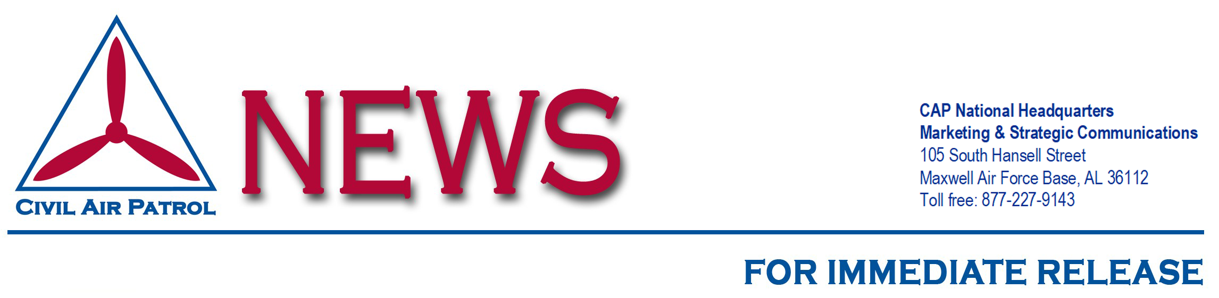
CAP Remembers Flight 217 During National Search and Rescue Week
MAXWELL AIR FORCE BASE, Ala. (Month Day, Year) – Civil Air Patrol’s 1979 Report to Congress painted a grim picture of the circumstances surrounding Rocky Mountain Airways Flight 217’s encounter with icing conditions.
Flight 217 left Steamboat Springs Airport for Denver on Dec. 4, 1978, with 22 passengers aboard. About an hour after takeoff the DHC-6 Otter commuter airliner’s pilot notified the Federal Aviation Administration of the icing problem and his intent to return to Steamboat Springs.
The plane went down in extreme conditions, in sub-freezing temperatures, wind and snow blowing 30-40 mph and reducing visibility to a few feet, and complete darkness at more than 10,000 feet in the Colorado Rockies, striking powerlines as it descended.
The Air Force Rescue Coordination Center alerted CAP’s Colorado Wing and other emergency services organizations at 8:12 p.m. Within an hour CAP dispatched seven four-wheel drive vehicles and members equipped with specialized direction-finding equipment to track the aircraft’s emergency location beacon. The terrain caused misleading readings as signals bounced off the surrounding mountains. The onsite mission coordinator directed the search team to the plane’s flight path.
Snowfall was so severe that the four-wheel-drive vehicles could not be used. A snowcat was brought in to aid the search even with the danger of driving off a cliff because of visibility issues. To ease the danger a rescue worker walked in front of the snowcat.
At 6 a.m. the search teams began to hear screams through the howling winds. Moments later the crew and passengers were found. Twenty-one lives were saved that day.
Statistics show that the probability of continued survival by the injured after a crash diminishes 80% after 24 hours. Civil Air Patrol continues to train to save lives and alleviate human suffering through myriad emergency services and operational missions. CAP performs about 90% of all search and rescue operations within the contiguous United States as tasked by the Air Force Rescue Coordination Center.
To learn more about CAP, visit gocivilairpatrol.com.
About Civil Air Patrol
Now celebrating its 80th year, Civil Air Patrol is the official auxiliary of the U.S. Air Force and as such is a member of its Total Force. In its auxiliary role, CAP operates a fleet of 560 single-engine Cessna aircraft and nearly 2,000 small Unmanned Aircraft Systems (sUAS) and performs about 90% of all search and rescue operations within the contiguous United States as tasked by the Air Force Rescue Coordination Center. Often using innovative cellphone forensics and radar analysis software, CAP was credited by the AFRCC with saving 130 lives during the past fiscal year. CAP’s 54,000 members also perform homeland security, disaster relief and drug interdiction missions at the request of federal, state and local agencies. As a nonprofit organization, CAP plays a leading role in aerospace education using national academic standards-based STEM (science, technology, engineering and math) education. Members also serve as mentors to 20,000 young people participating in CAP’s Cadet Programs.
Visit www.CAP.News or www.GoCivilAirPatrol.com for more information.
CAP Contact Info
[WING OR SQUADRON NAME]
POC: [NAME]
[PHONE/EMAIL]
Photo captions:
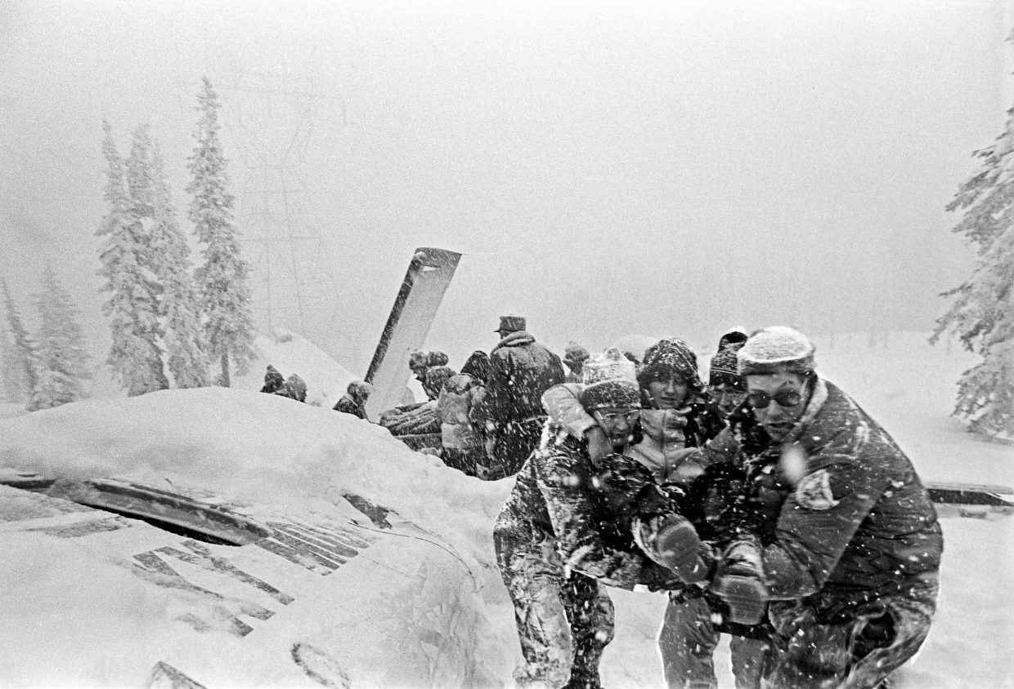“Flight217Rescue1”
Volunteers with Civil Air Patrol’s Colorado Wing haul survivors to safety after the 1978 plane crash on Buffalo Pass. (Source: Rod Hanna, Steamboat Springs)

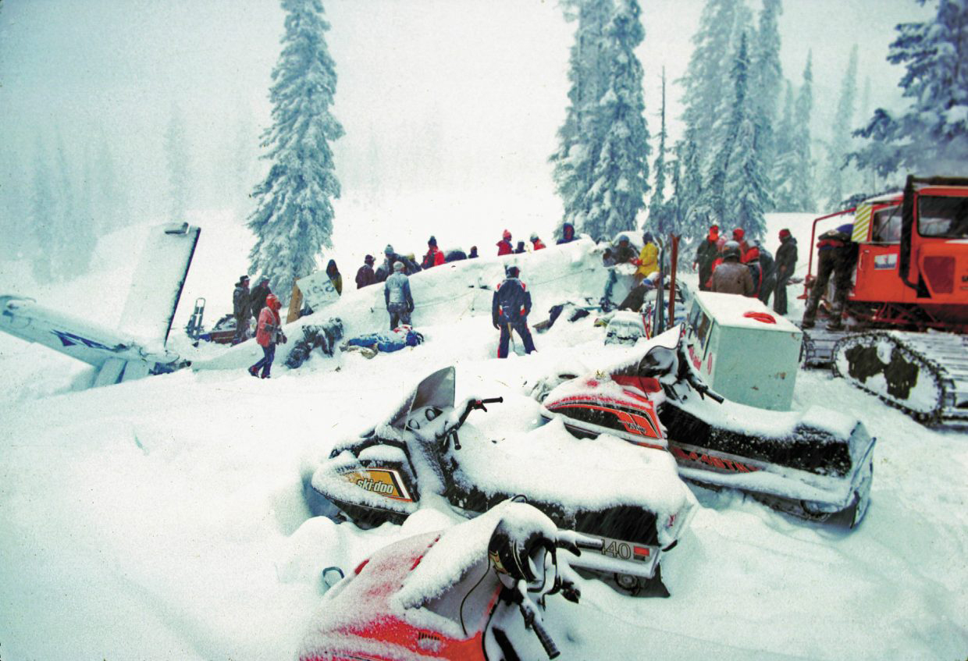“Flight217Rescue2”
Rescuers came on snowmobiles and snowcats to assist Dec. 5, 1978, at the scene of the plane crash on Buffalo Pass. (Source: File Photo, Steamboat Pilot)

