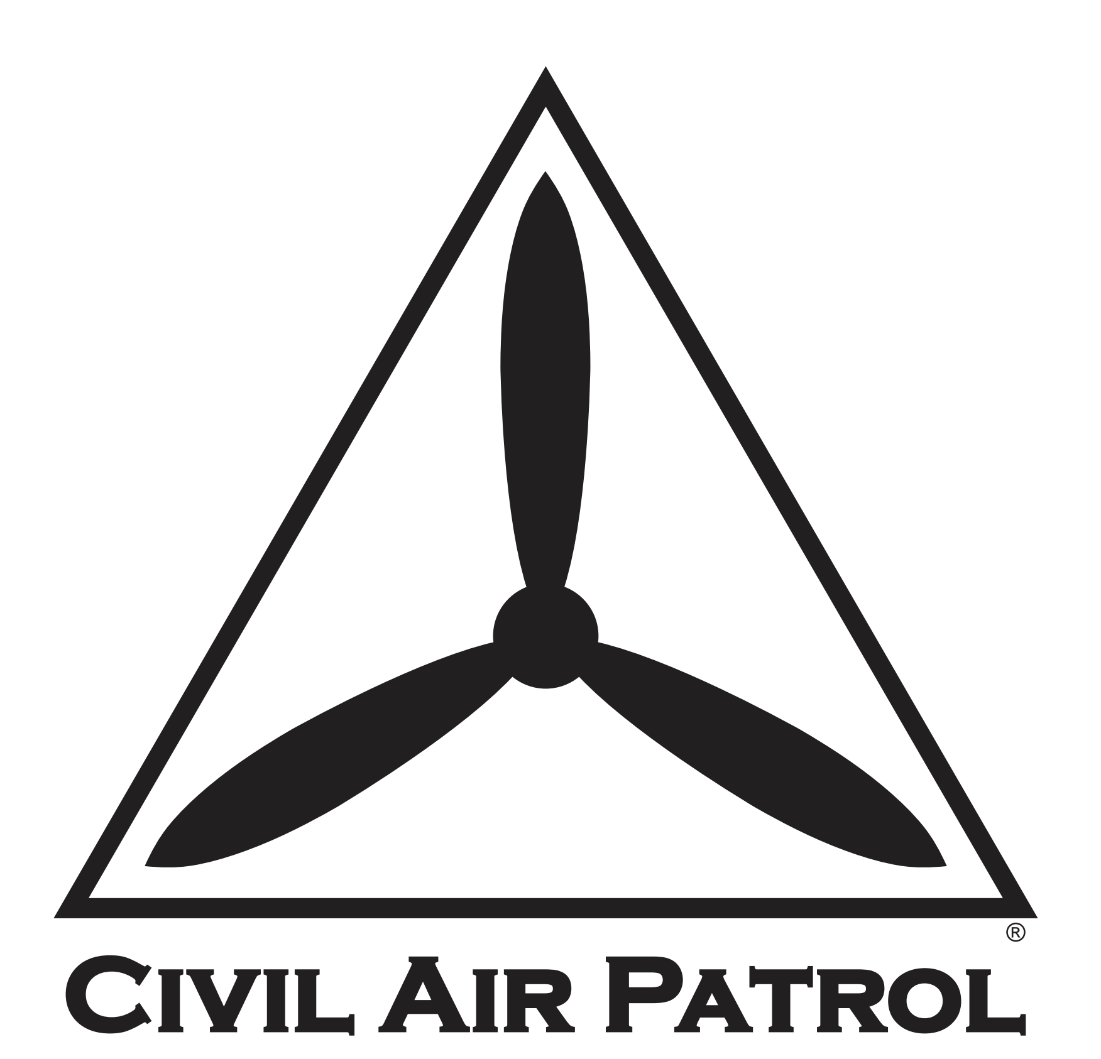

Post-COVID-19 Remobilization of the Membership Plan
  - Phase III: Resuming Overnight Activities (Bivouacs, Conferences, Encampments, etc)

XXWG
Completed dd MMM 2021
Template Updated 10 February 2021

This plan has been developed for ____(SPECIFY)_____ Wing, using the template provided by the Civil Air Patrol National Headquarters to enter Phase III, Resuming Overnight Activities.

Additional staffing and resources have been coordinated with _ (other wing or region, if applicable)_, to cover gaps in this wing’s available resources.

NOTE: Deviations from the template are authorized, but should be coordinated by contacting the COVID-19 Planning Team at COVID-19Plans@capnhq.gov.

Plan Coordinator and Point of Contact: _(e.g., Staff Officer or Incident Commander Appointed)_

Primary Phone: (____) _____ - ________

Primary Email: ____________@______________________.____

Narrative Summary of Coordination and Events To-Date in _(State)_ Wing:

_________(Complete below, and on additional pages as-needed.)__________

Phase III: Resuming Overnight Activities (Bivouacs, Conferences, Encampments, etc)
NOTE: Resuming overnight activities will not be done until Phase III, when most public health restrictions have been lifted, schools & businesses have reopened, and the forecasted risk is minimal.
Item# | Task | OPR/Assigned Personnel | Date Tasked | Suspense | Date Completed | Notes
3.1. | Verify current state-level guidance allows overnight events to resume
3.2. | Consult with staff officers to prepare for overnight activities
3.2.1. | Coordinate with Health Services
3.2.1.1. | Check state and local health guidance regarding gatherings
3.2.1.2. | Prepare to communicate with subordinate units on Health Services-related matters to continue selected public health measures
3.2.2. | Consult with Legal Officer about resuming overnight activities
3.2.3. | Coordinate with Director of Safety
3.2.3.1. | Verify proper planning and mitigation tools are available to staff and units
3.2.3.2. | Prepare to communicate with subordinate units on Safety-related matters
3.2.4. | Coordinate with Director of Cadet Programs
3.2.4.1. | Prepare recommendations for units regarding overnight activities
3.2.4.2. | Prepare bullets for units to incorporate when sending messages to parents about the resumption of overnight activities
3.3. | Query commanders of subordinate units to verify that local governments do not have more restrictive social-distancing guidelines than those at the state level

Phase III: Resuming Overnight Activities (Bivouacs, Conferences, Encampments, etc; continued)

Item# | Task | OPR/Assigned Personnel | Date Tasked | Suspense | Date Completed | Notes
3.4. | Email the CAP COVID-19 Planning Team at COVID-19Plans@capnhq.gov , and copy the Region Commander for permission to reinstate overnight activities
3.4.1. | Describe previous coordination accomplished
3.4.2. | Verify no jurisdictional restrictions are in place from State or Local Governments
3.4.3. | Set date to resume overnight activities, this is the start of Phase III
3.4.4. | Receive approval from the CAP COVID-19 Planning Team to resume overnight activities. Plan for one-week lead time.
3.5. | Publish the date that Phase III will begin to subordinate units
3.6. | Task Wing Director of Safety to communicate the following to subordinate units:
3.6.1. | Units may use steady-state RM forms to mitigate local risks
3.6.2. | Units continue to consider face coverings, hand sanitizer, and an emphasis on hygiene during meetings and activities
3.7. | Task Wing Health Service Officer to communicate the following to subordinate units:
3.7.1. | Health Services will continue to consider screening with no-touch thermometers prior to entry to the meeting or will require members to take their temperature at home prior to attending the activity
3.7.2. | Health Services will educate members on the importance of monitoring their health and avoiding participation in activities if sick

Phase III: Resuming Overnight Activities (Bivouacs, Conferences, Encampments, etc; continued)

Item# | Task | OPR/Assigned Personnel | Date Tasked | Suspense | Date Completed | Notes
3.7.3. | Health Services will continue to educate members on public health practices such as emphasizing hygiene, having face coverings, social distancing for those at high-risk, and common surface cleaning
3.8. | Task Wing Director of Cadet Programs to communicate the following to subordinate units:
3.8.1. | Units plan to resume formations, drill, and other close-distance activities as appropriate
3.8.2. | Units draft a local message to parents to inform them about what CAP is doing to keep Cadets safe while they participate in the resumption of all manner of activities in Phase III (a return to normal post-COVID-19 operations)
3.9. | Task Wing Director of Operations to communicate the following to subordinate units
3.9.1. | Identify flight operations permitted during Remobilization Phase III
3.9.2. | Identify requirements for Senior and Cadet members to return to flying as required

