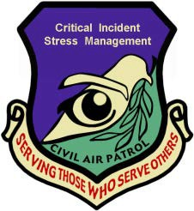

D) CISM / Peer Support CAN HELP with Resiliency
• Research shows that people will heal and recover faster from stress by responding to stress appropriately; this is the basis of peer support. Peer support can be as informal as "talking it over" with a trained peer or with a group.
Even if you do not want to speak about the incident there is still value in listening to others speak about it. It is
entirely voluntary, but highly encouraged to participate.
• CAP Peer Support can be considered emotional first- aid to help a CAP member’s normal coping skills. It is always confidential, supportive, and respectful; it is performed by a peer supporter – a CAP member just like you who knows how to get you the help you need.
• All people who undergo a traumatic or critical incident are affected. Talking and going through a CISM / Peer Support is a sign of strength and maturity because it means that you are taking an active role in your health.
• CISM is a proven process that will help you heal and return to your previous state of health by talking (or listening if you choose not to talk) about the normal process your mind goes through after an incident or trauma.
Requesting Help (24x7)
• If you would like to speak with a CAP Critical Incident Stress Management / Peer Supporter contact your Chain of Command, Wing CISM Officer, OR call the CAP National Operations Center at 888-211-1812 ext 300 (24x7) who will coordinate with the appropriate help that best fits your needs. Just say that you want to talk to the CISM Team. You don’t need to tell anyone why you want to talk.
• If you want to speak confidentially with a suicide phone coach call the suicide prevention lifeline at
1-800-273-8266 or text for free at 838255.

This document or the accompanying presentation found on the CAP Safety website may be used by CISM, Medical, Health Services, Nursing, or Safety Officers as one way to satisfy the monthly safety requirement (when approved by the local safety officer).
4

Critical Incident Stress Management (CISM) / Peer Support
Monthly Training – April 2015
Putting Problems into Perspective

CAP Senior and Cadet Members have significant stress in their lives. CAP wants to ensure that all members have coping mechanisms available to make all CAP members resilient to life’s challenges. Being able to mentally “get up” when knocked down is the goal.

Putting Problems into Perspective will help by:
• Increasing your energy and focus
• Reducing stress / anxiety / distractibility
• Steering you away from poor decisions
• Ultimately allow you to meet your full potential, both in CAP and in your life.

A) Catastrophic Thinking: When faced with a problem, people frequently think that the problem is the “worst ever” and have a difficult time focusing on anything but that “worse ever” problem. This can create anxiety, a feeling of helplessness, decreased focus, and a downward spiral of emotions that can reduce energy and increase poor decisions.

B) Replace Catastrophic Thinking by “Putting Problems Into Perspective”. One method is to use the Contingency Planning Method. Contingency Planning leads to purposeful actions and will “snap” you out of catastrophic thinking because you will be actively planning a response.
1

This document is informational in purpose. This guidance is
3 not intended to take the place of medical advice. 1

Contingency Planning Method of Putting Problems into Perspective (Adapted from U.S. Army Resiliency Program)

We are going to use the scenario of receiving a text message from a friend that reads “we need to talk tonight”.

- Step 1: List the Worst Case Scenarios
  - Write or mentally list the worst case scenarios and then ask yourself “if the worst happens, what will I do?”
  - In the scenario above: the friendship is over and “if the worst happens” I will increase my friendship with my other close friend.

- Step 2: List the Best Case Scenarios
  - Write or mentally list the best case scenarios. Be optimistic because this will “snap” you out of the catastrophic thinking.
  - In the scenario above: great news about something.

- Step 3: List the Most Likely Outcomes
  - Write or mentally list the most likely scenarios.
  - In the scenario above: the friend is upset about something but the friendship will continue. You remember that you had said that you would call that friend two days ago, but forgot to call them.

- Step 4: Create a Plan for the Most Likely Outcomes
  - Write or mentally list a plan for the most likely outcome.
  - In the scenario above: because you forgot to call the friend back two days ago, you think about several plans:
    - You could call your friend now and say that you are sorry about not calling them back.
    - You could text your friend back and say that you are sorry about not calling them back.
    - You could wait and call them later tonight and say that you are sorry about not calling them back.

2

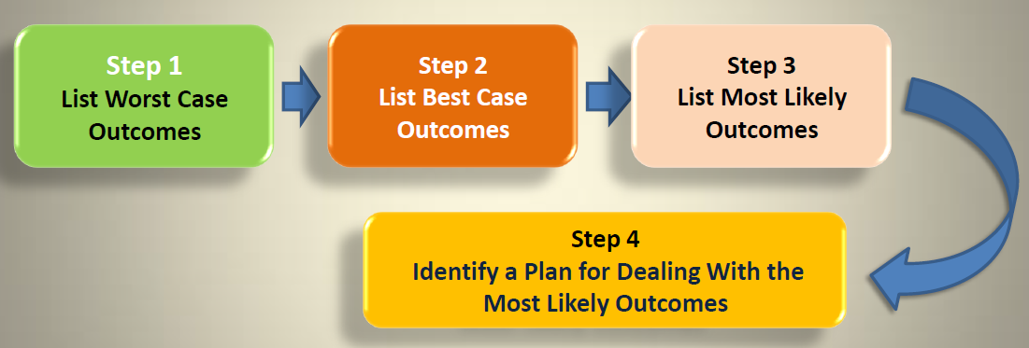

Key points of the Contingency Planning Method of Putting Problems into Perspective:

• It does not pretend that “everything is fine” but allows you to think critically and realistically about the problems and come up with reasonable solutions to the problem.

• It directly combats catastrophic thinking by developing strategies to deal with the MOST LIKELY outcomes.

• Perform the steps in order when you become paralyzed by catastrophic thinking.

• Consider talking a friend through the four steps if they become stuck in catastrophic thinking.

3

