Operations Plan Standard
DRAFT V1

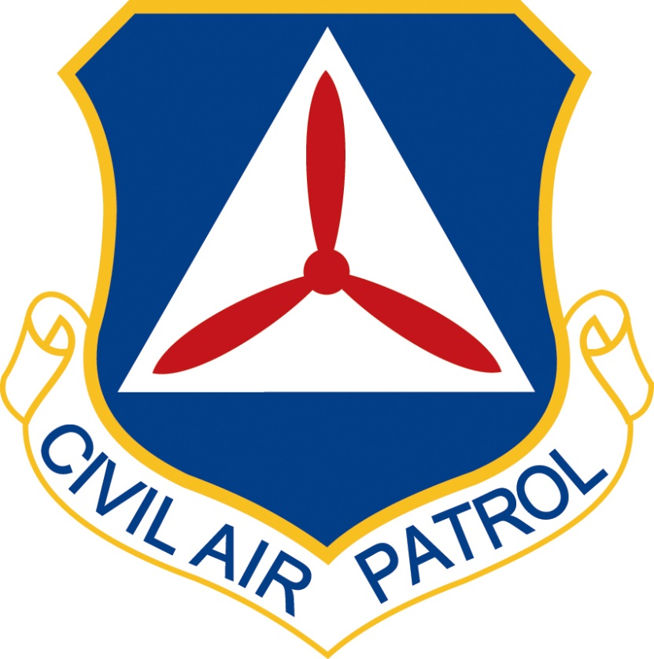

Name of Operation

Date Range of Mission

Name, Rank, CAP Name, Rank, USAF
XXWG Director of Operations CAP-USAF Det X/CC
Civil Air Patrol Civil Air Patrol – United States Air Force

This Ops Plan example outlines the standard format for all CAP Operations Plans. All sections and subsections outlined in this standard are required, however “N/A” is an acceptable entry if required. The Ops Plan needs to be fully coordinated through CAP-USAF prior to signature and needs to be signed before receiving Air Force Mission Approval in WMIRS, so be sure to coordinate the Ops Plan well enough in advance so as to not delay mission execution. A repository of approved Ops Plans will be kept on XXXXXX (gocivilairpatrol.com/) for reference.

Table of Contents:

Number Page

- General 2
- Application 3
- Flight Operations 3
- Administration 5
- Communications 6
- Cadet Participation 6
- Safety 6
- Staff Requirements 7
- Uniform Requirements 7
- Facilities 7
12. Logistics 7
- Military Support Requirements 7
- Public Affairs 8
- Contingencies & Emergency Services Missions 8

General

  - General Title (ex., VR-186 LLRS or RPA Escort)
Example: The CT Wing (CTWG) of the Civil Air Patrol (CAP) will provide aerial reconnaissance of the CT coastal waters and surrounding infrastructure as specified in this Operation Plan (OPLAN). This is the Long Island Sound Patrol mission.

The Long Island Sound is a crucial economic artery between the NY Metropolitan Area and Southern New England. Over 8 million people live close to its shores. The shore infrastructure is complex – arterial highways, rail lines, power lines and bridges cross the densely populated area in both CT and NY. Nine (9) towered airports surround the LI Sound, including LaGuardia and JFK. New London / Groton CT is home to a major US Navy Submarine base, General Dynamics Submarine Plant, and the US Coast Guard Academy. Several passenger ferries cross the LI Sound daily. There are conventional shoreline power plants in Northport NY, Norwalk, Bridgeport, Milford and New Haven plus the Millstone nuclear power plant southeast of Niantic.
  - Incident Command Post
List the location of the ICP. If none, then N/A.

  - Primary dates & times
Two to three sentences on the big events of the mission. When is the mission? Are there any pre-mission phone calls, briefings that aircrew/ground teams need to attend?

Example:
The mission with be authorized to open on 21 May 2020 and close on 31 March 2021.

Pre-positioning flights will contact the IC for approval prior to movement, only the IC or designee may release a flight for this event.

Incident Command Post staff briefing will be prior to each operational event. Mission will open for positioning of resources on 21 May 2020 and close on 31 March 2021.

  - Alternate dates
As required. If none, N/A

  - NHQ funding
This mission is funded by XXXXX.

  - Mission Symbol XX

  - Project Officer/Incident Commander

CAP Incident Commander/Program Manager:
Name, Rank, CAP
Email: XXX
Phone: XXX-XXX-XXXX (C)

CAP Project Officer:
Name, Rank, CAP
Email: XXX
Phone: XXX-XXX-XXXX (C)

  - Other Contacts

CAP Alternate IC:
Name, Rank, CAP
Email: XXX
Phone: XXX-XXX-XXXX (C)

Application

  - Qualification requirements
Add all necessary qualification requirements.

Example: Attendees shall be active CAP members with a valid CAP ID card in their possession, and present in a correctly worn CAP uniform. All members must have completed General Emergency Services and Basic ORM and have those noted in eService Operations Qualifications to participate in the event. Any member not having those basic qualifications will not be allowed to sign into the mission and will not be covered under CAP or USAF insurance. All Pilots will arrive with current Form 5 and 91 evaluations good for the duration of they’re attendance. Personnel participating as aircrew members will either be properly qualified or be a supervised trainee in accordance with CAPR 60-3.

  - Event capacity
The IC will determine the personnel needed to support each mission event.

c. Event enrollment procedures
Add all necessary procedures.
Example: Members who wish to participate are requested to contact the Project Manager in advance of the event.

Members desiring to participate should advise their Unit Commanders who will submit attendance information, transportation details, proposed inbound sortie requests, and any specific training requests to the IC. All participating members must have approval from their unit commander.

Flight Operations

The following section is an example of an RPA Chase Mission, so it is relatively in-depth. This section should include as much information about the actual operation as necessary. Maps, charts, mission details, etc. The Ops Plan should have all of the subsections included. If there is something that is not applicable to your mission, then N/A.

Aircrew Requirements:

An Aircrew consists of a qualified Mission Pilot (MP) and Mission Observer (MO). Two MPs may be used as a crew.

The operational week is Tuesday through Friday. The aircrews are expected to commit for a full week of activity Travel days will be Sunday and Saturday.

On monthly RSD, local aircrews will be required for operations, or aircrews already present may extend through Sunday.

Crew members for weekday operations will be at least one MP and one MO

MPs must have a minimum of 300 PIC hours, be current instrument rated for turbo C182 or C206 G1000 qualified, and night current.

MOs must be current, familiar with G1000 radio operation, and be able to assist the pilot with monitoring engine instruments.

Aircrew Training Requirements:

The MP must complete the following training tasks:

Thoroughly understand the “Chase Aircraft and Airborne Visual Observer Tactics, Techniques, and Procedures”, and the FAA Certificate of Authorization documents and be able to answer questions on their contents.

Attend a complete RPA mission briefing and debriefing.

Demonstrate the airborne join-up, escort to simulated restricted area and airborne join-up at simulated restricted area procedures, using the defined techniques. A second CAP aircraft may be used to simulate the RPA for training purposes.

Fly at least one RPA escort mission with a qualified escort pilot.

The MO must complete the following training tasks:

Thoroughly understand the “Chase Aircraft and Airborne Visual Observer Tactics, Techniques, and Procedures”, and the FAA Certificate of Authorization documents and be able to answer questions on their contents.

Demonstrate capability to effectively communicate with ATC or the RPA pilot and assist the pilot by monitoring engine instruments.

Attend a complete RPA mission briefing and debriefing.

Demonstrate ability to maintain visual contact with the RPA and communicate with the RPA pilot and/or ATC. A second CAP aircraft may be used to simulate the RPA for training purposes in both day and night conditions.

Fly at least one RPA escort mission with a qualified escort pilot.

Flight Operations

During night overwater operations, both front-seat crewmembers must be CAP qualified mission pilots, instrument qualified and current. The right-seat pilot need not be qualified in that specific aircraft.

During the duration of extended overwater flights, each occupant will wear FAA and U.S. Coast Guard or Department of Defense (DoD) approved personal flotation device (PFD). The aircraft will also contain a U.S. Coast Guard or DoD approved inflatable raft(s) of sufficient number and size to accommodate all occupants and will contain at least one pyrotechnic signaling device.

Constant wear U.S. Coast Guard or DoD approved anti-exposure or immersion suits will be worn by crew members on any pre-planned overwater flight when the water temperature is or is forecast to be 60F degrees or less. The Incident Commander (IC) may waive the requirement to wear the anti-exposure or immersion suit after reviewing appropriate safety and Risk Management (RM).

Mission-Specific Requirements

    - RPA operations outside Ellington Field Class D airspace require a manned escort. CAP aircraft, employed as escorts for the RPA, will be required to join with the RPA prior to exiting Class D airspace and escort the RPA to the restricted/warning area. When the RPA is ready to return to base, chase will rejoin just outside the restricted area and escort the RPA back to Ellington Field at the completion of the mission. These operations are planned for up to four weekdays each week and one weekend day per month during Regular Scheduled Drill (RSD). Support for exercises may also require changes to the schedule and additional support.

    - There is no requirement for airborne escort for RPA flights that remain within Ellington Field Class D airspace. The launching of escort aircraft for such flights will be at the discretion of the RPA Mission Commander.

Minimum altitude for all chase operations is 1000 AGL. Any chase operations below 1000 feet AGL will only be for an emergency and at no time will the CAP aircraft descend under 500 feet AGL. Any descent below 1000 feet AGL for an emergency is at the discretion of the CAP PIC.

    - CAP may be requested to perform escort operation related activities such as flying profiles for calibrating the Ground Based Sense and Avoid system or other tasks directly related to the RPA training program.

Basic Operational Elements

The basic concept of escort operations will be divided into the following areas:

Mission preflight planning and briefing

Takeoff and airborne join-up

Escort to restricted/warning area

Standby for potential early return

Airborne join-up in restricted/warning area

Recovery to base

Mission debriefing

Escort is defined as being close enough to maintain positive visual contact on the RPA and see potential traffic or terrain conflicts at all times. Normal location is in trail between the four and eight o’clock positions and in standard formation (1 NM, ± 100 feet).

One RPA is to be escorted each day. Due to CAP duty day limitations, a standby crew may need to be on-hand. While one crew is escorting the RPA outbound to the restricted area a second crew will be required to escort the RPA inbound to base. The chase crew change-out will occur while the RPA is in the restricted/warning area.

Administration

The following section is an example of an RPA Chase Mission, so it is relatively in-depth. This section should include as much information about the administration of the mission as necessary. The Ops Plan should have all of the subsections included. If there is something that is not applicable to your mission, then N/A.

  - Inbound/ Outbound sorties
- Inbound/outbound sorties are approved by the Incident Commander or their designee. Transport crews for each aircraft must be coordinated with the IC no later than three weeks prior to the event. You may not fly without an ELECTRONIC flight release. Please remember only the Wing Commander or their designated representatives can override disqualifications in eFlight Release.

Crews within five hours driving distance are expected to drive to Ellington JRB with CAP corporate vehicle or personal vehicle. Those beyond five hours driving may use commercial air travel. Limited exceptions for use of CAP aircraft may be granted. Use of corporate aircraft for crew transport may be used if the cost is less than commercial airfare and a reasonable option to driving.

  - Sortie Management

All sorties must be released in WMIRS electronically only by the IC or designee. FRO qualifications are required if you are not acting as an IC.

Sortie close-out data will be entered in WMIRS as soon after landing as practicable. Receipts must be uploaded within 48 hours or the expense will not be paid. IMPROPERLY RELEASED SORTIES WILL NOT BE FUNDED BY THIS EVENT.

  - Safety considerations
The IC or designee will cover all safety points upon release of the sortie, including the safe operations by aircrew and flightline personnel in the performance of their flying duties. NO PASSENGERS WILL BE SWAPPED WITH THE AIRCRAFT ENGINE RUNNING!

  - Mission paperwork

i. Crews for both airplanes and vehicles are responsible to ensure fuel receipts, RM sheets, Weight and Balance sheets for airplanes and CAP Form 108 & 109’s are provided to the IC for the event. He/she will ensure that fuel receipts, RM sheets, Weight and Balance and CAP Forms, if not on WMIRS, are captured and uploaded for each sortie for inclusion in WMIRS, in a timely manner.

ii. Aircraft will be refueled as necessary during the day but at least at the end of each days flying and must be noted on the CAPF104 in WMIRS. Inbound and related forms WILL be provided to the IC within 4 hours of arrival at KEFD.

iii. Crews will NOT be released for subsequent sorties until all paperwork required for each sortie has been submitted and approved.

iv. PILOTS ARE RESPONSIBLE FOR OBTAINING FUEL RECEIPTS AND COMPLETING AND SUBMITTING A TXWG FUEL USEAGE FORM TO THE IC. FAILING TO DO SO WITHIN 48 HOURS OF SORTIE COMPLETION MAY RESULT IN THE PILOT BEING RESPONSIBLE FOR PAYMENT OR REIMBURSEMENT OF FUEL FOR ANY SORTIE NOT PROPERLY DOCUMENTED AND REPORTED TO THE IC.

  - Daily SITREPS

i. SITREPS (Format for the SITREP is in Appendix A) will be sent to OPSCENTER@capnhq.gov and AFNORTH.CAP.OMB@us.af.mil at the completion of EACH DAY’S mission for all A and B Missions. Make sure to also Courtesy Copy the CAP-USAF Detachment Commander.

Communications

The following section is an example of an RPA Chase Mission, so it is relatively in-depth. This section should include as much information about communications as necessary. The Ops Plan should have all of the subsections included. If there is something that is not applicable to your mission, then N/A.

  - Requirements
Communication between the aircrews, ground teams and IC will make use of telephone, email, text messaging or radio.

  - Procedure
The ICP will have and maintain communications equipment for use during the entire event. All sorties will remain in contact with the ICP.

  - Required Equipment
    - All aircraft must have an operational VHF-FM aircraft radio. Use of an aircraft without an operational VHF-FM radio requires advance approval of the IC.
    - Ground teams should have VHF communication capability.
    - All operational sorties (air or ground) should have at least one cell phone and that number must be available in the ICP.

Cadet Participation

As detailed as necessary.

Example: No cadets are expected to be participating in this mission.

Safety

What forms are being used? How is the IC approaching safety? Below is an example.

  - Texas Wing ORM forms will be used at all levels of the event:
    - ICP – CAPFs 160 Deliberate Risk Assessment Worksheet, 160HL Hazard Listing Worksheet and/or 160S Real Time Risk Assessment Worksheet, will be completed for the Incident Command Post.
    - Operational Air Sorties – AIF RAW Aircrew must be completed in WMIRS as noted in Section 5, subsection i above.
    - Operational Ground Sorties – Hazards will be documented on the sortie within WMIRS.

  - All CAP operations involve some degree of risk. Participants must be alert and careful when operating aircraft or ground vehicles.

  - The IC will continually monitor all operations to ensure safety is not just talked about, but actually done correctly.

  - Any mishaps that occur on the mission will be reported IAW CAPR 160-2.

Staff Requirements

As required.

  - CP Staff members will be fully qualified or will be supervised by qualified members.

The following Incident Command staff are required:

Incident Commander (IC)

Project Officer (PO)

FRO

Any additional support staff as required by PO or IC

  - TX CAP will assign a Program Manager/Project Officer to oversee these operations.

  - Standby aircrew and members may perform other duties to assist and may include but not limited to: backfilling in the case of illness, a second instrument pilot for night overwater operations, relieve other crewmembers at the site, ground observer to assist the ANG, crew transport, and general support.

Uniform Requirements

All attendees must be in an authorized and complete CAP uniform worn in accordance with CAP regulations. Each member’s role should dictate the appropriate uniform. Mission Staff may be in a service or utility uniform depending on the level of contact expected with external participants or media.

Facilities

As required. If none, N/A.

Air National Guard Facilities at KEFD have been approved for this event.

Logistics

As required.

  - Billeting
As Required

  - Messing
As Required

  - Medical
Local medical facilities and by emergency number 911.

    - Ambulatory patients may be transported to facilities by CAP vehicle. All other transport should be arranged by calling 911. Care-flight is available for aero-medical transport.

  - Police and Fire
Local facilities and by emergency number is 911.

Military Support Requirements

As required.

Example: Use of Air National Guard facilities at KEFD have been approved for this event. Various ANG personnel will be available during the event. This has been coordinated in advance by the project officer or their designated personnel.

Public Affairs

As required. The below is an example. Keep all subsections. If not applicable, then N/A.

Media Contact
All media communication will be referred to the ANG PAO, Mission PIO or the IC. Participants are expected to refer all media inquiries regarding any mishap to the Mission Public Information Officer
  - Internal
The Public Information Officer (PIO) for this mission will be assigned by Texas Wing PAO, in coordination with the ANG PAO and the Project Officer.

  - External
News releases to local newspapers, radio and TV media will be made by the Texas ANG PAO in coordination with the IC and CAP Mission PIO. The CAP IC will coordinate releases with CAP/MAC who will coordinate with 1AF/PA.

Contingencies & Emergency Services Missions

As required.

Example: Any event may be suspended or terminated and CAP resources reassigned, at the direction of an active Emergency Services Mission Incident Commander, Texas Wing/CC, or Higher Headquarters CAP or CAP-USAF direction; otherwise, the event is expected to continue as planned.

*EXAMPLE*

Hurricane Maria Recovery Support to FEMA
SITREP #12
14 OCT 2019 / 13:00Z

SUMMARY: AFAM #20-1-5665A / Mission Symbol B10

The Civil Air Patrol (CAP), acting in its capacity as the U.S. Air Force Auxiliary (AFAUX), is providing support to the Federal Emergency Management Agency’s (FEMA) recovery efforts in response to catastrophic Hurricane Maria. This mission is a Defense Support to Civil Authorities (DSCA) and the approving authority for sorties is the 1st Air Force.

The mission is to operate sUAS flights to obtain geo-referenced orthomosaic images and 3D modeling of designated critical infrastructure repair projects throughout Puerto Rico.

Incident Commander: Mr Austin Worcester, CAP/DOU (XXX) XXX-XXXX

CAP Team Leader: Lt Col Joel Shreenan, CAP/DOUA (XXX) XXX-XXXX

The funding source for AFAM #20-1-5665A is a FEMA MA which is valid through 20 October 19

ACTIVITIES WITHIN THE 24 HOURS:

SUNDAY, 13 OCT 19

The flight portion of just in time training was conducted for the replacement team members. Training occurred at target 17A. NADIR and oblique images were obtained.

Higher end imagery processing continues at HQ CAP.

Contact information and initial coordination was received and done with the PR USACE site POCs.

0.72 sUAS flight hours was conducted
A total of 6.31 sUAS flight hours have been conducted during this mission

887 sUAS still images and no (0) video image were captured
A total of 4,990 sUAS still images and one (1) video image have been captured during this mission No (0) Ground level images were captured

A total of 340 ground level images have been captured during this mission

A total of 5,330 still and one (1) video image have been captured during this mission, from which orthomosaic and 3D models are being generated of the targets.

MA obligated funds expended 13 Oct 19: $2,116.72 Total MA obligated funds expended to date: $24,481.19

ACTIVITIES WITHIN THE NEXT 24 HOURS:

Teams will conduct sorties to image the remaining four PREPA targets on Monday, 14 Oct.

Teams will begin conducting sorties to image the additional PR FEMA/JFO targets for PA on Tues, 15 Oct.

Site coordination with the USACE site POCs will be conducted.

Demobilization and AAR meeting planning will commence on Tuesday, 15 Oct.

HQ CAP/DOU will continue image processing to attempt higher end visual images and 3D modeling and point clouds for lessons learned.

ISSUES:

Equipment: A charging block for the standard InstantEye batteries that was assigned to the HLS variant has failed. A replacement has been overnight shipped from IER to HQ CAP for transshipment to the AOR.

Wildlife: A protected bird species is in the area of our operations in the rain forest. Should we encounter nests or believe they are in the target area, we will have to contact PR Wildlife Management Agents before proceeding.

Weather: There is an 80% change of heavy rain and thunderstorms across the AOR today (14 Oct). Rain and wind curtailed flight operations on Saturday, 12 Oct.

List any other issues you are encountering, or just Nothing Significant to Report (NSTR).

AIRCRAFT IN USE

Tail # | Avionics | Special Equipment | Location | Hours to next MX

COVs IN USE

CAP VEH ID | License Number | Make / Model | Location

